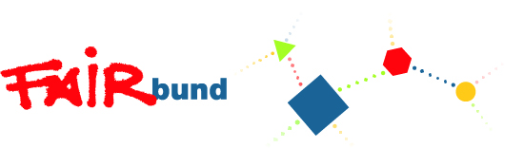
BName of the project(s) you are interessted in:

When can you start your voluntary service and how long can you stay?:

Personal Data:

Last name, first name:

Sex: F □ M □ D □

Date and place of birth:
Nationality/ Nationalities:
Address:

Country:
Mobile phone please with country code:
E-Mail:
Participation number in ESK:
You should be registered here: https://europa.eu/youth/solidarity_de

Emergency contact Data:
Last name, first name:
Address:

Phone number:
E-Mail:
Your sending organisation
(in case you’ve got already one)
Name:
Akkreditationnumber/ Quality Label:
OID Nummer:
Address:
Contact person:
Phone number:
E-Mail:

About Yourself

➢ Please describe your family background (who is your family and what do your family members do)

➢ Where are you from? Please tell us about the place, you come from.

➢ What do you do currently?

➢ Which languages do you speak at which level? Please describe: understanding, talking and writing. Use the competence levels: A1-C2 (you can use European competence ...).

➢ What is your general state of physical and mental health? Is there anything important we should know about you and your health?

➢ How did you hear about the project you are applying for?

➢ Have you ever visited Leipzig?

➢ Why are you interested in this project?

➢ What do you expect from this experience?

➢ Have you already done any kind of voluntary work? Please describe which kind, where and for how long.

➢ Why would you like to volunteer in Leipzig?

➢ Have you had any previous contact with children/pedagogy/socio-cultural work?

➢ Do you have any work experience or practical skills?

  What are your main interests or hobbies?

➢ Please describe your previous experiences in other countries, your contacts to people from other nationalities, races and cultures:

➢ Personal statement (Is there anything else you would like to tell about yourself?)

Declaration
Please note if your application progresses further you will be requested to provide:
- Certificate of vaccination status (for kindergarten)
- Police Clearance Certificate from home country

Statement of consent to the processing of personal data: I hereby authorize the use of my personal data in accordance to the GDPR 679/16 - "European regulation on the protection of personal data".
I, the undersigned, certify that all information contained in this application is accurate.

Date: Signature:

Please attach to this application:
- a photo
- motivation letter (1 page)
- your CV
Your application will be taken into consideration ONLY if ALL these documents are attached. Please send the documents via email to: euprojekte@fairbund-leipzig.de

(We would highly appreciate to receive your application written in German, but in case you are more confident making it in English, please do it so.)
Kontakt:
FAIRbund e.V. · EU-Austauschprojekte ·
Rückertstraße 10 · 04157 Leipzig · Deutschland
Ansprechpartner: Rüdiger Vandrey
Tel: 0049-(0)341-2316122 · Fax: 0049-(0)341-2316120 ·
euprojekte@fairbund-leipzig.de

